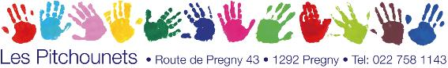

ENROLMENT FORM

Family names: ___________________________ First name (of child):______________________
Birthdate: _______________________________
Nationality: ______________________________ Mother tongue:___________________________
Address:__________________________________________________________________________
Private phone nr.: ________________________ E-mail address:___________________________
Father first name:_________________________ Mother first name: ________________________
Father’s cell nr.: __________________________ Mother’s cell nr.: _________________________
Father’s work nr.: _________________________ Moher’s work nr.: ________________________
Father’s profession: _______________________ Mother’s profession: ______________________
Person to contact in case of absence or emergency:______________________________________
__________________________________________________________________________________
Correspondence by mail ? yes no
Resident : In Pregny-Chambésy Not in Pregny-Chambésy

Non-tax payer :

Name and telephone number of the child’s doctor:_____________________________________
Health and accident insuranse:______________________________________________________
« Responsabilité civile » (third-party liabiliy insurance):_________________________________

Note: Les "Pitchounets" does not take responsibility in case of accidents; insurance remains the responsibility of parents.

I will pay the monthly fees: by e-banking at the poste

Remarks:________________________________________________________________________

Date: Signature:

